PYTHON ASSIGNMENT 1
Raunak Kr. Singh
Cyber Security and DF
UID: 24071246

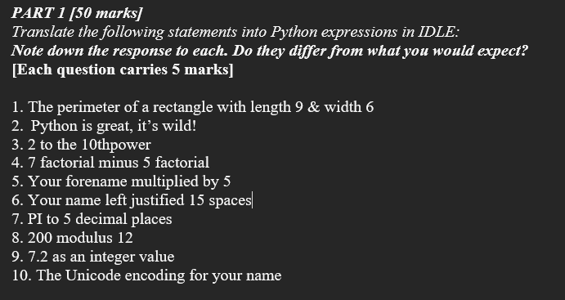
Questions:

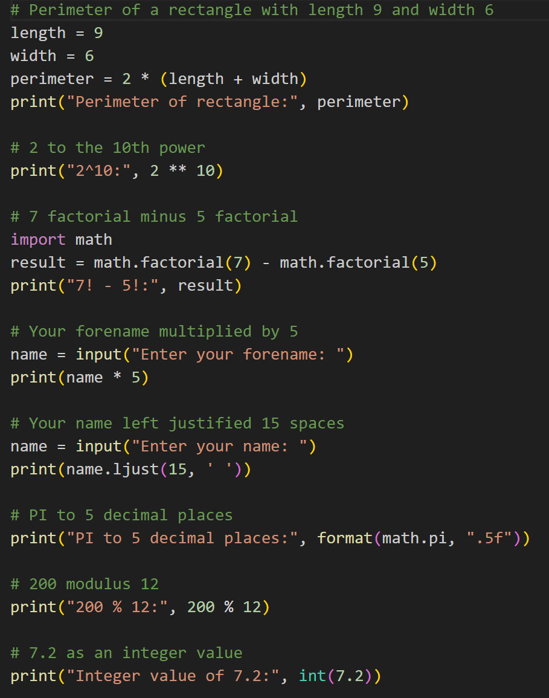

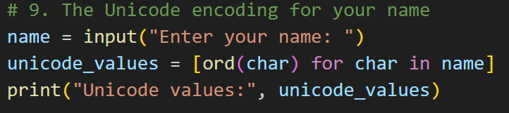

Output:

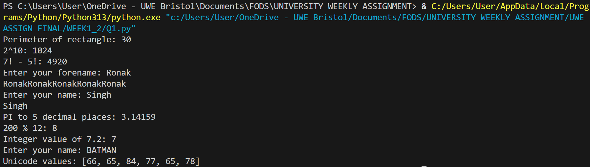

PART 2

Questions:

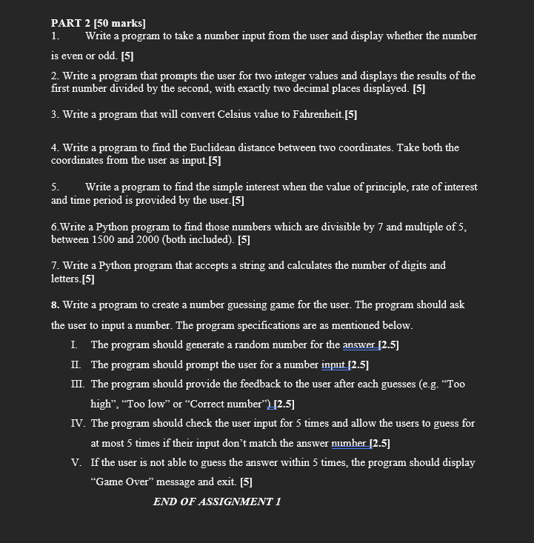

1)
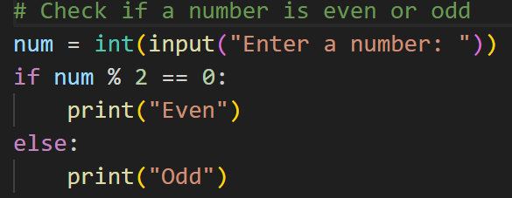

Output:

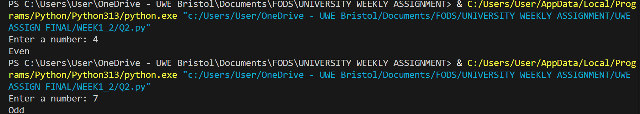

2)

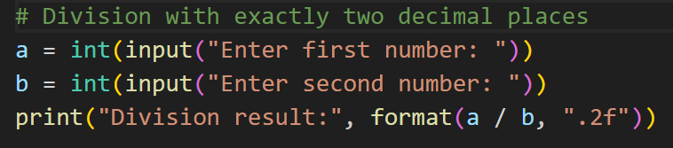

Output:

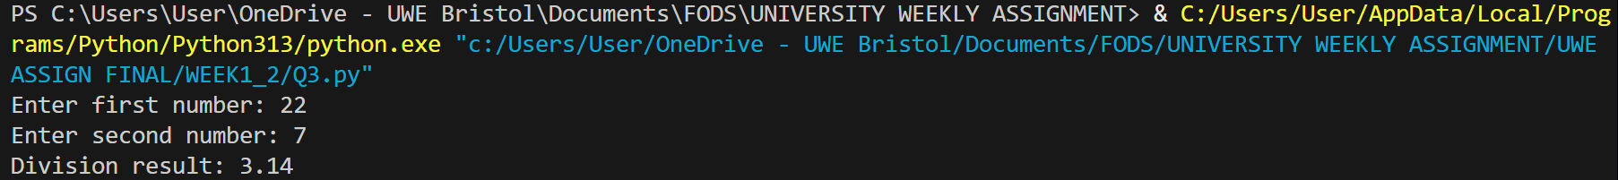

3)
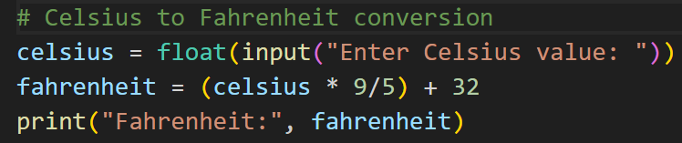Output:

4)
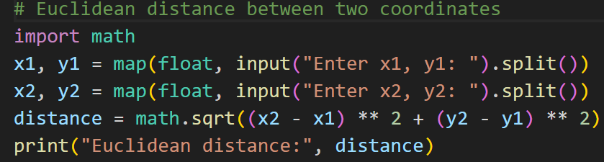

Output:

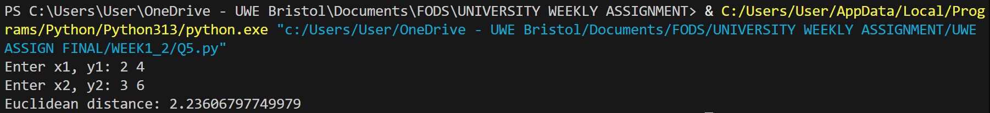

5)

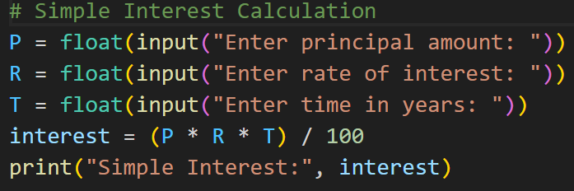

Output:

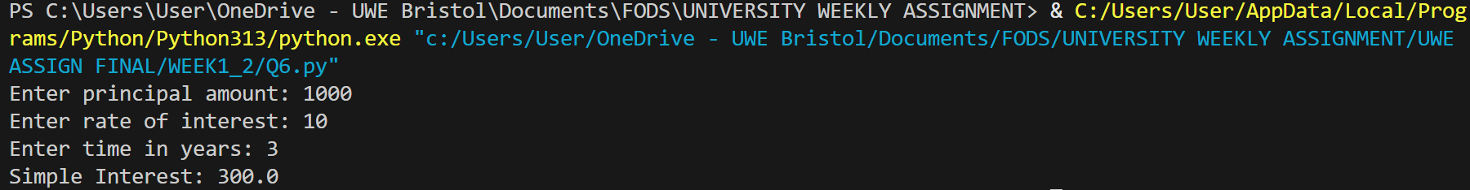

6)
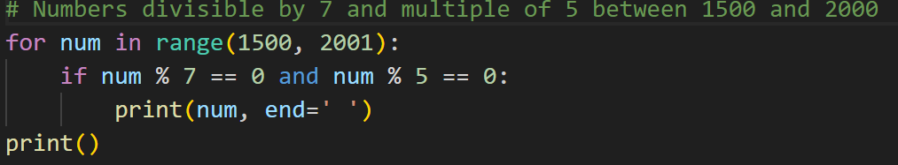

Output:

7)

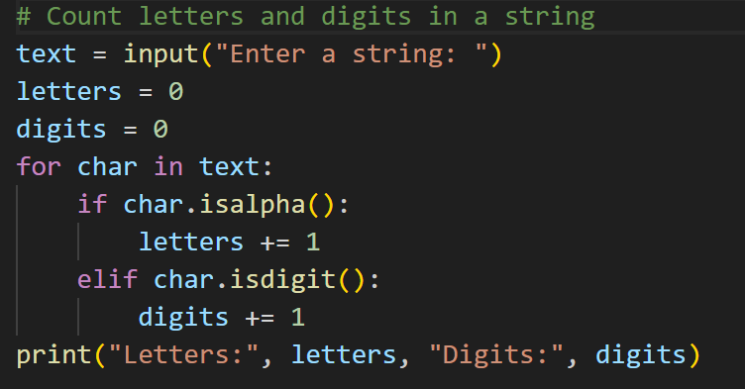

Output:

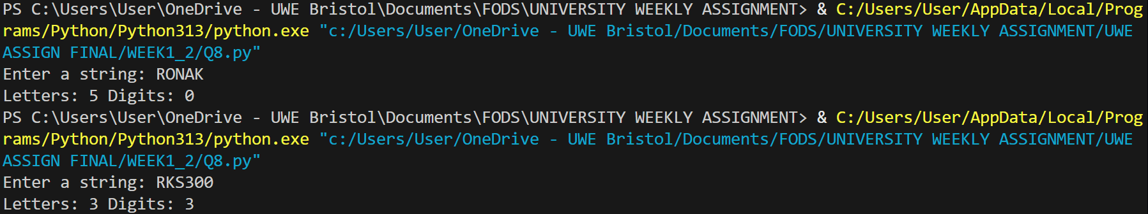

8)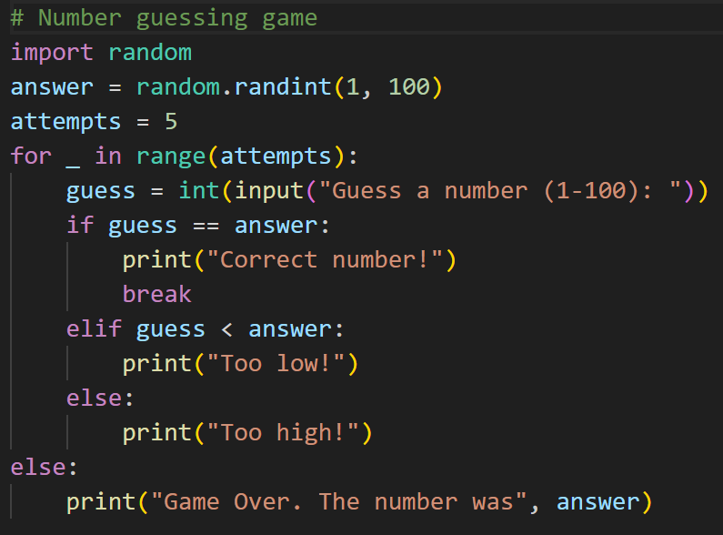

Output:

